Computational Complexity Issues

The main question of security, ‘What is a possible computation?’ derives from the consideration of security of cryptosystems against computational atttacks. In mathematics, this is called computational complexity theory. This section consists of the complexity issues along with discrete loagrithm problem.

“The discrete logarithm problem for the group G may be stated as:

Given g E (belongs to) G and a E (belongs to) (g), find an integer x such that g ^x =a.” (page 49 number 1)

The statement of the problem above is the primary aspect that needs to be considered. Firstly, there is logic to discuss the discrete logarithm problem in an arbitrary semigroup; however, in many cases the curiosity is in precise examples of finite cyclic groups.

The above statement has precisely eliminated that a may not be possibly within the cyclic group generated by g. There is another way to state the problem:

“Given a, g E (belongs to) G, determine if there exists an integer x such that g^x=a, and if so, find such an x.”

There could be more difficulty to solve this version of the problem. In order to resolve the discrete logarithm problem, analysing an algorithm could be utilised and therefore it would have an affect, as to go ahead with the analsis we should be aware that a E (belongs to) (g). From now on, the assumption will be made that the group G is cyclic, with G = (g), so the initial statement of the problem can be used.

The statement “given the group G” should be defined in an unambiguous way. There could be many abstract ways that groups could occur; the following gives a few examples:

- the imaginary quadratic field’s class group, which is received by the discriminant
- an elliptic curve over a finite field or rational numbers, where a group of points occur, received by the equation of the curve and the specification of the field
- Galois group of a polnomial
- Finite Abelian group which is received by invarian factors or generators and relations.

The following assumtions need to be made for the group G, which are as follows:

- We know efficient algorithms for testing equality of group elements
- We know an efficient algorithm for multipling any two elements of the group
- The group if finite, generated by g, with known order n. (page 52,53)

The classification of computational problems is the aim of the field of computational complexity whilst corresponding the level of difficulty. An example of a random polynomial time reduction between two computational issues is the discrete logarithm algorithm which could be used to determine the order of the base for the logarithm. This type of reduction can be seen as a partial ordering which is induced from the computational issues depending on the complexity dealt with, and valuable data could be given on the intrinsic complexity of the issue. In this particular situation, it could be hard to determine the discrete logarithms because it is initially used to determine the order of that base in the group.

Reduction

Firstly we have to consider a few simple methods which will decrease a discrete logarithm problem in a cyclic group G to discrete logarithm problems in different subgroups. In order to start it is essential to mention all the rules involved. It is not too difficult to multiply and take inverses in G, which is required in this case. There could be a problem in some cases where there could be a possibility that two elements could be equal, for example, suppose the group is viewed as a sructure with proportions, or there maybe a group of binary quadratic forms, however, an assumption should always be made while carrying out a group operation, that the cost of deciding if the two elements of G are equal is of the identical magnitude. Another assumption is that the group elements could have allocated symbols so that they could be kept.

The first reduction

Suppose the cyclic group G has the order n and n is factored significantly as n=u,v, u and v here are coprime, and thus gcd (u,v) =1. So now the issue of solving a discrete logarithm in G is decreased into solving for order u and v of the discrete logarithm in the subgroup of G. Specifically, if G = {g}, then g^u generates the subgroup of u-th powers in G, which has order v, and in the same way g^v generates the subgroup of v-th powers, which has order u. Solving the discrete logarithm l_u, l_v, where

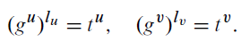

By performing repeated squaring you can solve the powers g^u, g^u, t^u, t^v. (Buhler and Wagon 2008)

Adopting the extended Euclidean algorithm may discover the integers a, b do au + bv =1. So
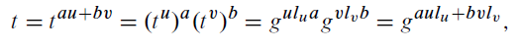

and we come to the conclusion for discrete logarithm of t is aul_u + bvl_v.

The next reduction

This reduction assumes that the order is a prime power of G, so for example, p^a, where a > 1. The discrete logarithm issue of order p in the cyclic subgroup of G, could have been reduced to a from the dicrete loagarithm in the group. Suppose we need to discover the l from g^l=t. In the base p, if we add in the l, where l is satisfied for a smallest positive value, then
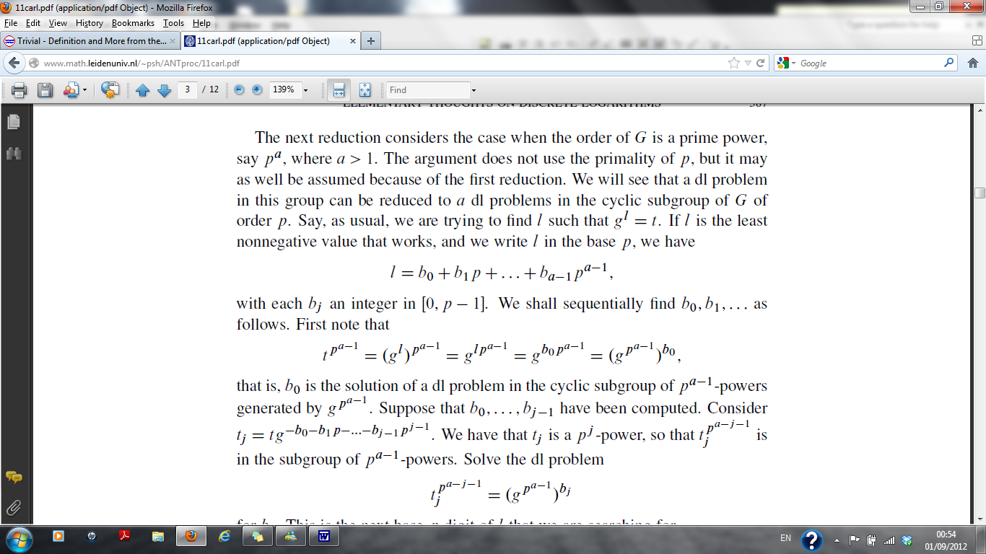

For each b_j being an integer in [0, p-1]. b_0, b_1….should be discovered in order. Consider the following

The p^a-1 powers which are generated by g^p^a-1 in the cyclic subgroup, b_0 is the resolution of the discrete logarithm problem. Assume the calculation for b_0…..b_j-1, has alread been done. Note that
.

it can be observed that t^j is a power of p^j, and therefore j_j^p^a-j-1 is in the group with powers of p^a-1. The discrete loarithm issue for b_j needs to be solved.

we now need to look for the the base p digit of l.

To demonstrate such reduction, we need a help of an example. So consider an example where g=11, t=17 in (Z/101Z)*. It is sufficient to solve two discrete logarithm issues for every groups of order 2 and 5. it is sufficient because 100 is the order of the group. So 17^25 = (equivalent to) -1(mod 101), order 4 in the subgroup, the element 17^25 should have 2 as their discrete logarithm i.e. l_25=2. The two problems have now been solved for the order 2, the first one is 0 and the second on, therefore l_25=0+1.2=2).

We should now find l_4 for 11^l4 = 17^4 = 95(mod 101), the order of 25 is being solved for the discrete logarithm in a cyclic group. The discrete logarithm calculation had been decreased to two in a group of order 5. Firstly we have to calculate 17^20 = 95^5 = 1(mod 101), this concludes that l_4 is a multiple of 5. In addition, 11^20 = 87(mod 101). For the 95 modulo 101 we need to look for a power which corresponds to 87, and the solution is 0,1,2,3 or 4. it is obviously not 0 or 1 so we try 2 which works. So l_4 = 0+2.5=10. Next we consider (-6).4+1.25=25, therefore (-6).4.10+1.25.2=-190 is the discrete logarithm for 17. 10 is the smallest positive discrete logarithm.

We can now control the group order, however, this could not be the situation most of the time, we should decrease the problem to smaller situation as we have just seen above which could be done by running a factorisation algorithm on the order because some discrete algorithms are most of the time difficult in practice than factoring. Smaller situation could be easier, unless in some cases working on subgroups which could be just as hard as working in the full group.

Algorithms for the Discrete Logarithm Problem

When considering the calculation of discrete logarithms keeping in mind the rigouros proof of such behavior is important. this can be done by differentiating how the algorithms are created, for example whether its practical or sructured. Note that when calculating discrete logarithm over GF(2^k)*.

Algorithms for general groups

This part is dedicated to any omitted information regarding the group for the algorithms. To create the algorithm which is straigtforward and clear is the one that consist a table of every n powers along with g which is easy to find the group elements which is contained in the table and find the discrete logarithms. As a minimum, with n times you can calculate the table, and to store the table it will take O(n) space. The main aim of algorihms is to advance such limits.

This final catergory contains the calculus methods but these are not of great interest to us under the context of finite fields GF(2^n), and so this review will centralise on algorithms belonging to the first two catergories only.

Baby steps, giant steps

We are going to look at a group G={g} of order n and tE(belongs to) G. Consider 0_< l _< n-1 and g^l=t, the main aim here is to discover an integer l. We now have to restate the discrete logarithm l in the base m and assume m= [root n]. Thereafter, l = b_0 + b_1m where 0-<b_0, b_1-<m-1. Its suffice to discover b_0, b_1 and clearl discover l.

There are two lists that we need to arrange. The first one is 1,g…..,g^m-1 this is by taking ‘baby steps’ whilst the second one is t,tg^-m….,tg^-(m-1)m b taking ‘giant steps’. These two list should have general elements in them as g^b_0 =tg^-b_1m. t can be easily discovered straight away because the general elemnents helps us.

Comparison paragraph

For the order of the group element g, an n is the upper bound it will still execute for the shanks algorithm. An integer n is chosen for the upper bound, with such integer if it’s excessively small the method is performed over again until it provides the solution. This algorithm, Shanks, can compute the order of g in time o(n^1/2 log n). This was the initial job of the shanks algorithm.

The shanks algorithm is viewed as hypothetical interest, as its practical. On the other hand, Pollard has an equivalent time and the space is smaller. There are two ways in which this will progress. The first is as well as an upper bound the algorithm needs the order of the group and the other is regaring the running-time bound and a validit is required. Some arguments are still made about the assumption of approximate running time.

Historical Perspective

Cryptography has now stood at the edge of a revolution. Cryptographic devices have become more expensive as they have increased in standard allowing commercial applications such as remote cash dispensers and computer terminals to make good use of them. Further, the expanding of inexpensive digital hardware untied it from the limitation of designs of mechanical computing. Consecutively, to decrease the need of secure key distribution channels and to provide a written signature in an alternative way, it is necessary to produce these types of applications for new kinds of cryptographic systems. Simultaneously, going from ancient art into science, if theoretical developments in computer science and information theory are taken into consideration, then these identify and prove secure cryptosystems.

When networks controlled by computer have been expanded for communication, there has been guarantee for cheap and easy contact between the computer itself and users from different parts of the world, substituting most mail and a lot of excursions with telecommunications. A lot of applications have to ensure such contacts are secure from eavesdropping as well as unlawful messages.

The main issue with cryptography is privacy, ensuring that unauthorised extraction of information is avoided from communications through an insecure channel, although anyone communicating today will have to use the same key that no other individual is aware of. In order to do this, such a key should be sent prior to the communication by a secure channel, for example, private courier or registered mail. In business, it is usual to have a private discussion with no such associate, on the other hand, it will be unlikely if contacts would delayed for a long time so keys can be provided b physical terms. Significant teleprocessing networks have a concern with the key, as the cost and postponement which is forced is an obstruction to transmit of business communications.

In order to remove the requirement for a secure key distribution channel public key distribution system presents an alternative way. In this way anyone who wants to communicate with each other can do so until the shared key is found. Anyone else eavesdropping the conversation will not be able to compute the key from what has been heard.

Another problem, which could be a resolution of how to substitute up to date business communication by teleprocessing sstems is authentication. In business the contracts are official by signatures. When a contract is signed the proof of the terms and agreement can be presented in court if necessary. Written contracts with signatures always need transmission and storage. To replace the written to digital, the authentication should be able to be checked by anybody where any users have produced the message; however, the message should not be produced by another person for example the recipient. There is only a single person who initially creates a message and countless people could receive it, which can be seen as broadcast cipher. This requirement cannot be met from current electronic authentication.

When cryptographic problems have come across, together with communications and computation, their theory of information along with computation theory has started to provide tools for resolution in classical cryptography for major issues. Cryptography research mainly contains the codes which are unbreakable; however, it has been broken until this century proposed. The ‘one time pad’ was originated in 1920s and it was revealed that it was unbreakable.

Finding the plaintext with no information about the key, is the security of many cryptographic systems apart from the difficulty of computation to the cryptanalyst. The field of computational complexity and analysing algorithms is where the problem lies, which both are the latest study of solving computational issues.

The obvious complexity in calculating logarithms in a finite field GF(q) with q elements. Let

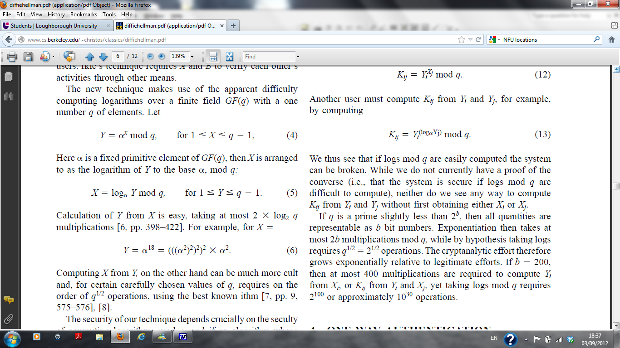

Where (alpha) is a fixed primitive element of GF(q), and X is arranged to the logarithm of Y to he base (alpha), mod q:

Its quite simple to compute X to Y, ensuring the most 2 * log_2 q multiplications. An example, X =

However, when computing from X to Y, it could be quite difficult any value chosen for q has to be explained, such as the order of q^ ½ operations, which is used by the most ithm.

The method that has been used, the security mainly relies on the security of computer algorithms mod q, and m would be broken if the complexity expanded to log_2q. The statement of the problem may permit some simple algorithm, however, right as an alternative, permits a proof of the actual difficulty of the problem. The best q chosen q^1/2 as it’s a best measure of the difficulty of the problem and a good common algorithm for using logs and mod q as well as being quite near optimal. A number which has been chosen uniformly, which users have produced from integers {1,2, …,such keeps X_i secret, but places
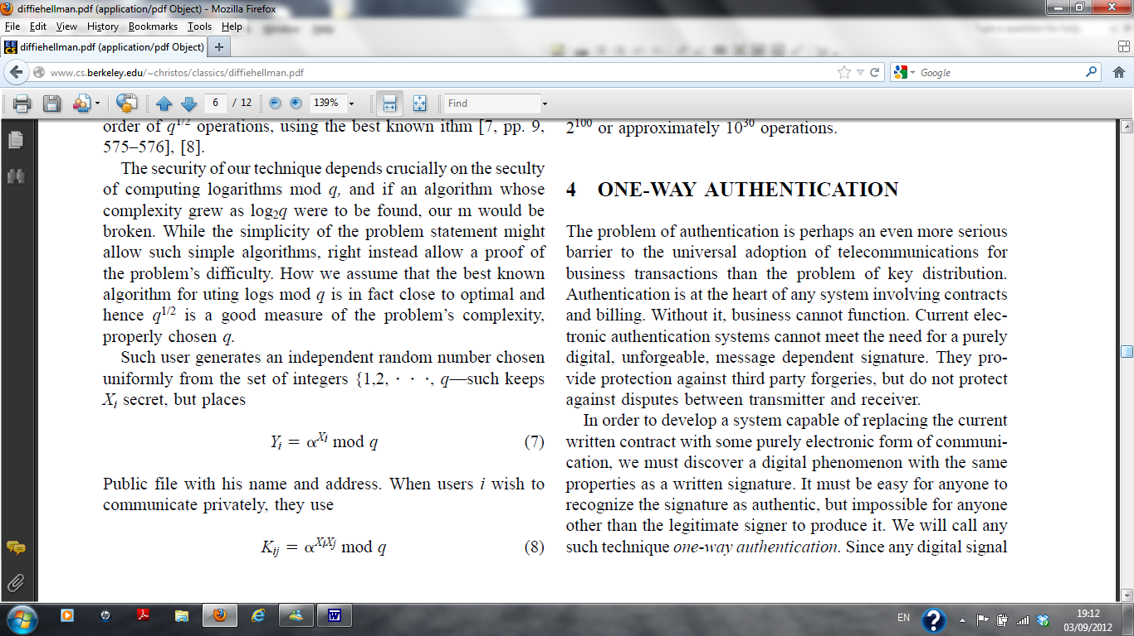

Public file with his name and address. When private communication is used by i users, then the following becomes their key,

K_ij is acquired by user i and this is done by acquiring Y_j as of the public file. Let

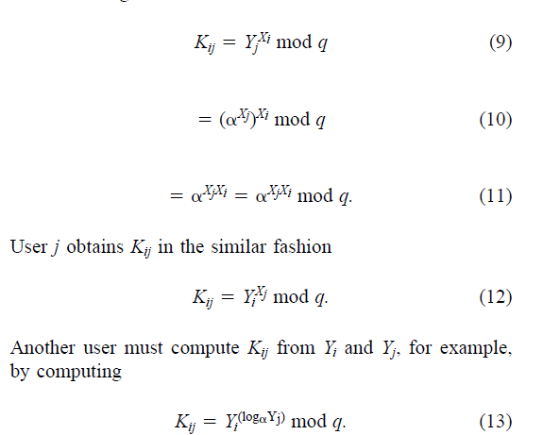

It is evident that the system can brake without difficulty if the logs mod q is known. Although there is no evidence that the system is secure if logs mod q are not easy to compute, and X_i or X_j always have to be computed before K_ij can be computed from Y_i and Y_j.

If 2^b is a little more than q which is a prime, thereafter every quantity are seen as b bit numbers. Exponentiation then takes at most 2b multiplications mod q, while by hypothesis taking logs requires q^1/2 = 2^1/2 operations. As a result, the crypt analytical effort exponentially grows with rightful efforts, to obtain X_i to Y_i, or Y_i and X_j to K-ij, when b=200 then a maximum of 400 multiplications are needed, as well as logs mod q which needs 2^100 or roughly 10^30 operations.

In the past the growth of cryptography has not indicated public key systems and a one-way authentication system, but it can be seen as a natural growth of development in cryptography going back to hundreds of years.

As already mentioned, an important aspect of cryptography is privacy; an aspect that was uncertain during the first stages of cryptography. An example of this could include the Caesar Cipher; when a letter is substituted by the third place, for example, A is carried to D and B is carried to E and so on, the Caesar cipher cryptosystem relies on the security by ensuring the whole process of encryption is kept secret.

The general system had to negotiate when the telegraph was generated, this happened because of the difference between the general system and a precise key. An example of this is theft of crypto graphical devices, with no negotiation of upcoming encrypted messages in new keys. Kerchoffs codified this theory, where in 1881 it was stated that any correspondents should hesitate with the negotiation of a cryptography system. Around 1960 however, keeping messages a secret was out of place as cryptosystems came across and therefore it was quite strong to tolerate a common plaintext cryptanalytic attack. Such enlargement reduced the part of the system that had to be kept secret from the public, so before it was shown, had to remove dreary convenient as rephrasing diplomatic dispatches. In order to decrease secrecy, public key systems are sustained and there were restrictions to computations in cryptography systems before this century. These computations were done by either hand or normal slide rule like devices.

The actual revolutionary commmenced just after World War I but it’s currently coming into a final result. Extraordinary machines were built for encrypting. Cryptography was restricted to operations that could be done with easy elecromechanical systems, till there was expansion of normal purpose digital hardware. The expansion of digital computers has untied it from the restrictions of computing with gears and the search is authorized for better types of encryption to only cryptographic principle.

http://www.mccurley.org/papers/dlog.pdf (1)
http://www.math.leidenuniv.nl/~psh/ANTproc/11carl.pdf (2)
http://www.cs.berkeley.edu/~christos/classics/diffiehellman.pdf (3)

